**Prolog KB1 to KB5 (SWI Prolog)**

**___________________________________________________________________________**

**1.KB1:**

girl(ishu).

boy(harsh).

playingOnGrond(ishu).

playingChess(harsh).

athome(mom).

angry(daddy).

Output-

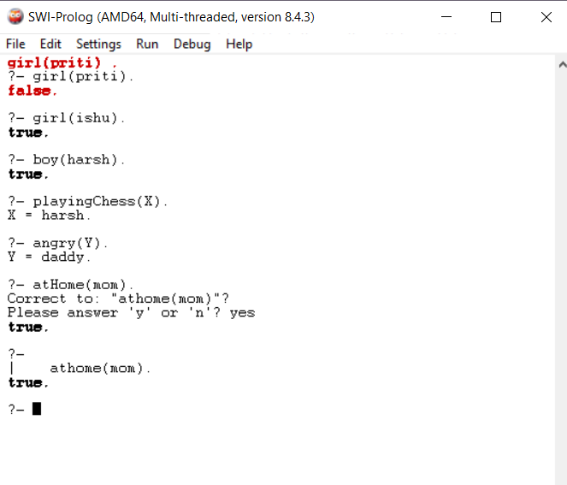

**2.KB2:**

girl(ishu).

boy(harsh).

playingOnGrond(ishu):-girl(ishu).

playingChess(harsh):-boy(harsh).

Output-

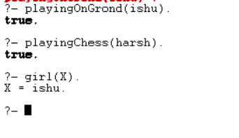

**3.KB3:**

girl(ishu).

happy(ishu).

sad(ishu).

boy(harsh).

busy(harsh).

playingOnGrond(ishu):-girl(ishu),happy(ishu).

study(ishu):-sad(ishu),happy(harsh).

playingChess(harsh):-boy(harsh).

playingChess(harsh):-busy(harsh).

Output-

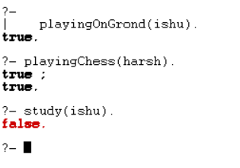

**4.KB4:**

girl(ishu).

girl(priti).

girl(srunu).

boy(harsh).

boy(soham).

study(ishu,priti).

study(priti,suhani).

study(soham,suhani).

playing(srunu,harsh).

Output-

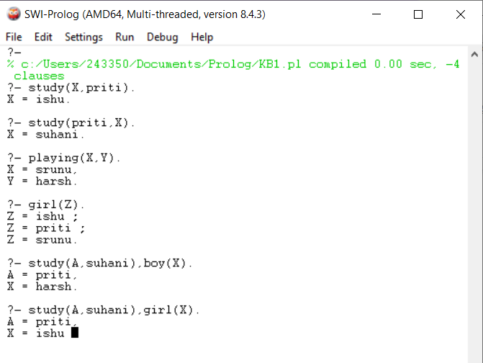

**5.KB5:**

loves(vincent,mia).

loves(marsellus,mia).

loves(pumpkin, honey_bunny).

loves(honey_bunny, pumpkin).

jealous(X,Y):- loves(X,Z), loves(Y,Z).

Output-

